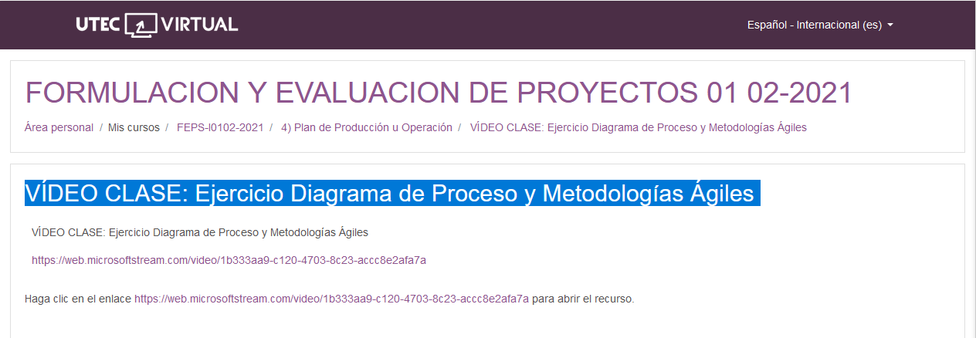

<https://web.microsoftstream.com/video/1b333aa9-c120-4703-8c23-accc8e2afa7a>